Monitoring a young person’s usage and behaviour over social media like Facebook, Twitter and develop patterns

MSc. PROJECT DISSERTATION SUPERVISOR: HOSSEIN GHOMESHI

**Sreekanth Kumar Paluru**

**Student ID: 20113286**

Table of Contents

Table of Figures 3

Abstract 4

INTRODUCTION 4

Background 4

Problem Statement 5

Research Aim 5

Research Objectives 5

Research Questions 5

Research Rationale 5

Significance of the Research 6

Research Structure 6

Research Gap 6

LITERATURE REVIEW 6

Excessive Use of Social Media by the Youth 6

Different Social Media Platforms and the Impact on Youth 7

Effect of Social Media Platforms on the Actions of Today’s Youth 9

Social Media Platforms and Evolution of Future Generation 9

Change in Behaviour, Development, and Mindset of Youth Due to Social Media 11

RESEARCH METHODOLOGY 11

Introduction 11

Research Procedure 12

Research Design 12

Research method 13

Research philosophy 13

Research Strategy 13

Research Approach 13

Data Collection 14

Sampling 14

Population 14

Data Analysis 14

Research limitations 14

Ethical Consideration 14

EXPERIMENTATION 15

Introduction 15

Data Interpretation 15

Data Interpretation using Code 18

Discussion 21

CONCLUSION AND RECOMMENDATIONS 22

Introduction 22

Recommendations 23

References 23

# Table of Figures

Figure 1 - Research Procedure 12

Figure 2 - Research Design 12

Figure 3 - Age Class Interval Distribution. 16

Figure 4 - Distribution of Survey Population, based on Cities. 16

Figure 5 - Distribution of Survey Population, based on Profession. 17

Figure 6 - Average Followers on Instagram based on Profession. 17

Figure 7 - Average Number of Posts on Instagram. 18

Figure 8 - Usage of Social Media on Weekends vs on Weekdays. 18

Figure 9 - Probability Mass Function for Hypothesis 1. 19

Figure 10 - Violin Plot for Hypothesis 2. 19

Figure 11 - Boxplot for Hypothesis 2. 19

Figure 12 - Relation between Instagram and Facebook Preferences. 20

Figure 13 - Correlation Matrix Representation for Figure 12. 20

Figure 14 - Representation of Hypothesis that People with more degrees tend to have less affinity towards social media. 20

Figure 15 - Representation of the Hypothesis that People in the Working Profession tend to visit Social Media less than others. 21

Figure 16 - Representation of the Hypothesis that Working Professionals are not shifting to Instagram as much as others. 21

# Abstract

Social media has become the crucial element of business as well as the personal life of an individual. Social media can positively and negatively influence the individual due to its higher reach. Youth are getting involved more in the social media platforms, this concern has both positive and negative impacts on the lives of the youth. In consideration of the positive impact, youth are now able to make life more interactive, learn new skills and get to know about the innovations of the world. These platforms are providing ample opportunities and skills that can shape their academic as well as professional careers. Most of the youth get indulged in spending more time on Facebook and Twitter. This makes them less interested in personal life, less interested in sports, and physical activities. The virtual world is more fascinating and is distracting the youth from reality. Thus, it is important to analyse and monitor the young person’s usage and behaviour over social media.

With the help of primary data collection techniques and graphical interpretation methods, the following research attempts to analyse and monitor young person’s usage and behaviour over social media. The dataset used is created by a third party using a survey questionnaire technique, where approximately 1600 participants are considered from all over India for participation. Based on their responses, the relation of social media usage and change in a young person’s behaviour is analysed. The majority of respondents have agreed that participants social media is changing the behaviour of young person’s and behaviour change is highly influenced by usage time and pattern.

# INTRODUCTION

## Background

In modern times social media platforms are attracting a great volume of users. Social media platforms could be defined as web applications that help users to interact with each other. The working of a social media profile could be understood in certain steps, in the first stage the user creates a profile on the platform, later the user interacts with other users in the next stage, and in the final stage, the users share images, thoughts, videos, and feelings with other users through the social media platforms. Many different social media platforms are being used by the public, but some of the most user engagement platforms are Facebook, Instagram, Twitter, and Snapchat. These web applications have the highest number of users throughout the world (Tripathi, 2017).

It is one of the most influential ways through which people get into entertainment. In the initial days of social media, the sole purpose of the platforms was to allow people to interact with one another. Before the evolution of social media, the world was dependent on email and telephone calls. These applications enabled users throughout the world to get engaged with other people. Communication became very easy and interactive with these social media platforms. These platforms allowed the users to chat, make video calls, post videos and pictures. All these things were very innovative and engaging in the initial’s days of social media platforms. People are getting engaged in these platforms because of the versatility and the type of engaging content which is available to them. It has been observed that most of the population which is getting engaged in social media platforms is of the youth. Although people from all age groups are engaged in social media platforms, the majority of the users are from the age group 15 – 24. These figures help define that youth are spending more time over social media platforms, majorly over Facebook, Instagram, and Twitter (Anderson and Jiang, 2018).

Focusing on the advantages which these platforms are providing to the generation. Social media is offering user engagement to companies and brands. Most of the influencers and social media personalities are making a good amount of money from these platforms. This proves that social media has evolved very much from the primary purpose of offering an interaction platform. Now Facebook and Twitter are not only used to interact with friends and family, but all the big brands, businesses, and personalities are using these platforms to enhance user engagement. Youth are getting engaged with the brands and are endorsing the products, against which the youth are getting paid (Dilci and Eranıl, 2019). This is one of the most innovative ways to make money. Although this method of generating money is not very easy, it requires patience and generating quality content. When the profile of the individual or any brand gains a good number of users and subscribers then they start to generate money.

It is very necessary to be active and aware of the facts of life. Youth are using social media to gain details about the new developments of the world, the youth also get to know about the area which could help them to reform the life if laid proper focus upon. In most cases, it is observed that Facebook, Instagram, and Twitter are helping youth in becoming more social, this is a positive impression as it helps in avoiding depression and isolation (Charoensukmongkol, 2018).

Furthermore, there are adverse effects of social media platforms when it comes to youth engagement. The trend to follow social media personalities and influencers is taking over the world. Many youths are spending lots of money to make life, like social media personalities. These things could be constructive if the youths learn something and work hard to make a better living, but most of the time this thing does not happen. It could also be considered that youth are losing interest in the reality of life, rather in the phase of imitating the living of other people the personality of the individual is getting dimmer. Despite all the adverse effects of these platforms on the lives of the people, it could be observed that the engagement level of the youth is increasing at a rapid rate (Fabian-Weber, 2019).

## Problem Statement

It has become very necessary to monitor the usage of social media platforms like Facebook, Instagram, and Twitter. The young generation is getting involved in the criteria and is aware of the fact that the excessive usage of social media could lead to a bad impact. It should be considered that the youth which is indulged in the usage of social media excessively have been in this virtual world since its beginning. It simply means that the people who have lived a life without social media could easily differential between the life and the quality of living which has been impacted by excessive social media usage (Baccarella, et al., 2018). While the youth that has seen social media from the beginning could not understand the lag which excessive use of social media is making in life. The major issue is that the usage of social media should be done in a limited amount, there must be certain capping or other restrictions. The guardians should also consider that excessive use of social media could hinder the actual essence of living of the youth.

## Research Aim

The research aims to monitor and analyse a young person’s usage and behaviour over social media like Facebook, Instagram, and Twitter and to develop the patterns between social media usage and behaviour change.

## Research Objectives

* To identify the social media usage among the youth and monitor their usage patterns.
* To examine different social media channels that are being used by Youth along with positive and negative aspects of identified channels.
* To analyse the impact of social media platforms on the behaviour of youth.
* To perform the data analysis and develop the pattern between social media usage and its influence on youth behaviour.
* To conclude and form recommendations that can be used for further research.

# Research Questions

How social media platforms are influencing youth person’s behaviour and define the positive and negative aspects of the influence.

# Research Rationale

The rationale of the study helps understand the actual needs for which the research is being done. In consideration of the topic, the gravity of context is to monitor the level at which the youth is getting indulged into social media platforms like Facebook and Twitter. The research also helps understand all the effects which are observed on the youth because of the excessive use of these platforms. It is very obvious that the excessive use of anything leads to a fatal result, and social media is one of them. Another major point of concern is that the strategy and the marketing techniques used by social media platforms like Facebook, Instagram, Snapchat, and Twitter gets evolved continuously. So, these applications do not let the user feel distracted from them. The users invest most of their time in these applications. Through this research, the future effects and the impressions which are made on the youth can easily be evaluated (Abi-Jaoude, et al., 2020).

# Significance of the Research

The significance of the research helps depict the importance of researching the concerned topic, in consideration of the topic it could be understood that the impact of social media needs to be gauged. If the impact of the excessive usage of social media platforms is not valued properly then it could result in a bad impact. Social media platforms are the requirement of the modern world, these platforms help in understanding the transformation which the world goes through. It could not be made possible that the use of social media is removed from the lives of the people, majorly the youth. The reason behind this is that there are many positive impacts of using social media platforms. Companies, people, organisations, celebrities, governments, NOGs, and many others use these platforms to communicate important details. This is an aspect of usage and should be done in a calculated manner (Abi-Jaoude, et al., 2020). The excessive usage needs to be avoided, and the research helps in understanding this impression in depth.

## Research Structure

Research structure is the defined pathway through which research needs to go, it has different chapters and all the chapters have independent significance. The division of these chapters has been done so that every layer of the study is done flawlessly.

**Introduction:** This is the first chapter of the research; in this chapter, the aim and objectives of the research are defined. Moreover, the significance and rationale of the research are also portrayed in the introduction chapter.

**Literature Review:** This is the second chapter and, in this chapter, the concepts proposed by different authors are published. With aid to the similar concepts proposed by different writers, it becomes easy to understand the details and concepts related to the research topic.

**Research Methodology:** This is the third chapter of the study, and it helps define all the techniques, methods, practices which are required to execute the research properly. The techniques of data collection and data analysis are depicted in the research methodology.

**Data Analysis:** This is the chapter that includes the details on the topic with aid to the concepts and details proposed in the complete research. The complete evaluation of the research is done in this chapter fourth.

**Conclusion and Recommendation:** This is the last chapter of the research and helps gain the complete details as a conclusion on the topic. Moreover, the recommendations are based on the results which are extracted from the conclusion.

## Research Gap

This segment helps define the details which are not covered by the previous researches, in consideration of the study. It could be portrayed that the research highlights the advanced impacts which could hinder the normal usability of the youth. Moreover, the social media platforms are observing constant upgrades and evolution so this research helps simplify the ideas to meet the challenges. As the issues related to social media are changing, it is very necessary to change the level of solutions provided against them.

# LITERATURE REVIEW

## Excessive Use of Social Media by the Youth

According to Berryman, et al., (2018), social media can become a medium of self-expression, a creative platform, and an open space. It is an innovative way of being in an open space. Social networking is a forum for meetings with other creative people, for inspiration, and for sharing their trips. It also allows users to communicate with people and enables young people to maintain connections across their lives. Social media is a major part of the social and artistic lives of many young people. Social networking is fun for young people and children, the social media networks are rolling out as a catalyst for mutual friendship and interest, boosted identity explorations, and increased family connections. Social media networks also help to bond a greater connection between people and different generations. It is also a key part of the way to communicate with friends, especially for older teenagers. Social networking can link children and young people with common interests to global online communities. This may include, support networks for young people with disabilities or medical problems, adolescents with LGBTQI, and children with special cultural backgrounds. So social media becomes the platform to talk about those interests and shared information, such as sports, television shows, music, or hobbies. The users can feel connected and well-being, by involvement with extended families and colleagues and through taking part in global and local online communities.

As per the reflection of Décieux, et al., (2019), The youth should sense and consider the relationship and atmosphere so that their environment can appreciate and value the many viewpoints and views of the world. They will explore fields of concern and use the networks of education using too many ideas exchanged on a variety of platforms. The young generation is mostly liable for developing technical and networking competencies. The internet is now a part of everyday life, it is important to learn how to communicate digitally to prepare and inspire children and young people to reconnect with family and friends. Border removal to build links social networking removes conference constraints and maintenance of people and builds cross-border connections. This will be an excellent opportunity for children with disabilities or who felt like they cannot interact with their families, to express their thinking and interests. Social networking is useful for improving access to family members who live thousands of miles away from families from a local area. It helps them to maintain relationships and keep them in touch to easily share their lives.

According to Aparicio-Martinez, et al., (2019), social media are also the place to look for support, it offers ways to help friends and families who might have a specific problem. On the other hand, it may be a place for certain young people to seek help if they experience something that they do not speak to anyone nearby. For social campaigning, social media may be useful, social networking can help young people become conscious of a certain cause of actual impact or for a change. To build a good digital footprint, young people are also allowed to use their accounts as individual resumes to share their successes, demonstrate their skills, and develop their good online portfolio in the future. The sharing of life and experiences with other people helps to give people a feeling of understanding that 24 hours a day access to media can have a detrimental impact, and makes people feel less affected by what they see. People can learn about the plight of others by using social media and by video sharing. It makes users feel closer and more ready to reach. So youth could learn about bad and good experiences from social media networking and connecting.

As per Goodyear, et al., (2018), social media are also helpful to learn the etiquette of communication there are plenty of platforms available for online communication. The social media talk or relationship team organisations encourage young people to learn certain social values, social labelling, and the respect of a group, even though they are involved in the public space. People may not always be right, but the majority of them want to succeed in this field. By using social media, a young person can observe and learn about righteous social behaviour. Young people take pictures, videos and find things to post and comment on consistently. Social media is becoming a practice of discovering and criticising new contents and ideas and values, to represent beliefs. In many of their lives, the production of content will play a major role. Learning what to share and how to evaluate it whilst they are young, is a skill they are developing constantly without even being aware. This type of consistent behaviour develops constant learning.

Social media benefits from their ability to enhance the ability of a young person to share, care and compare. This helps them to concentrate on the secrets, photos, appearances and insecurities that have always been important for young aged people. It is no wonder teenagers were some of the utmost social media users. Social networks need to be seen as an effective psychosocial support resource and risk shifting when young people are mature and independent. It is an amazing advantage of social media for the company to publish organic content for free. This provides businesses with many ways to communicate with important leads free of charge (Megele, et al., 2020). This is one reason why businesses like to use these channels.

Young people share the material they want to see and the websites allow them to share photos, videos and more on social media. It is a great way to get the brand out and help them get to know more about the company. Hence social media networking also creates revenue and becomes a livelihood for many social media influencers. Social media channels are becoming more popular day by day and the generation which is getting most of the advantages are young age people. From the beginning to the end social media has proven itself as a vital element of today’s young generation’s needs.

## Different Social Media Platforms and the Impact on Youth

According to Kumar, et al., (2018), in previous years the use of social media has increased exponentially. People are utilising the internet and network services at a huge level to stay connected with each other. The author demonstrates that social media is being an incredible tool for businesses and communication between the population. Social media communication can also be used in organisations and it can also aid in the success of businesses and firms in various ways. Almost one-third population of the planet adequately operating social media services. As per the author, to maintain the better connection of young employees of the company use of social media becomes popular in organisations. The youth generation uses different types of social media handles to connect. At present time many social media platforms are available for daily use. For the official and carrier purpose, mainly Gmail and LinkedIn are the most popular social media handles which are used by youths.

Apart from this to stay connected people are using Facebook, Instagram, Twitter, and Snapchat. The author demonstrates that social media is being a big part of teen and youth populations. Almost 45% of the youth population are available online to stay connected (Shahbaznezhad, et al., 2021). The use of social media in youths may be beneficial for the users. With the help of social media handles young generation can develop their interest in new things to find out new problems of real life. Youth people can express their new ideas and thoughts on social media without any hesitation. The social media handles are important for exploring new talent of a particular place. With the help of social media, people are not feeling much far from each other because the use of social media provides easy communication and connectivity for the people.

In the words of Nygren. (2019), Facebook, Snap chat, Instagram, Pinterest, WhatsApp, Twitter, and TikTok are some of the most popular social media networks among youngsters. Young generation using all these social media platforms to stay connected with each other. These social media platforms are also used in the field of education to share important documented and knowledge among all the other youngsters. Users can broadcast their thoughts and ideas with all these social media platforms. Apart from these social media platforms some gaming tools and platforms are also becoming popular among youngsters. The author demonstrates that online multiplayer gaming is also becoming popular in the youth generation. Some famous multiplayer social media gaming applications are Clash of Clans, The Sims, League of Legends, and World of Warcraft.

Online Gaming chat rooms are another popular way for young people to engage with others who represent their role in gaming. According to the author, the use of social media means the upload and share the content and communication from one place to another place.

The young generation in social media can build an online platform to chat, upload photos, videos and share links (Akbar, et al., 2017). Teenagers make fun, build up friendships, exchange information, explore ideologies and establish family relationships in social networking. Social networking is indeed a follow-up to one offline and personal conversation. It is usually a key aspect of how older adolescents engage with their peers. The young generation can communicate online social media networks with global communities that have similar interests. For successful reflection of the youth generation, the usage of social media platforms became a major part.

Under the reflection of Purohit and Chan, (2017), mainly social media users are divided into four different categories as Experts, Sharers, Developers, and Bonders based on their uses and benefits. Grouping of people is based on the online behaviour of social media handlers. The author demonstrates that social networks can be uses for connecting the peoples. The young generation can create discussions on social media platforms. It also has many media sharing networks such as media use and sharing of pictures and videos. Based on the use of social media, users can take benefits of the online available connectivity tools of social media. The author describes that to stay connected with the people and brands young population can use Facebook, Twitter, and LinkedIn.

This social media platform provides benefits to the users by sharing the knowledge of brand awareness, relationship building, customer service, and many more. The media sharing group of social networking has Instagram, Snap chat and YouTube which is highly used by a new generation and youth. The author describes that on these social media handles users can share and follow videos, photos, live videos, and other media (Ernst, et al., 2019). These social media channels are trending in recent years because of the popularity of the young generation. In present time the discussion is needed for the solution of every problem the author describes some social media channel which provides the discussion platform for the young generation and internet users. Digg, Quora, and Reddit are some common and popular social media handle, which provide a discussion platform for the youth generation. On these discussion platforms, people can also share news, information, and opinion. So, these social media channels are the most common and popular in the youth generation.

Under the reflection of Wohn, et al., (2013), the use of social media has increased in organizations. It becomes popular due to the development of technology and internet connectivity. In beginning, the use of social media was limited but it becomes much popular in organizations due to its popularity and use. There are many social media channels are available for the user's benefit to make proper communication between two ends. The author demonstrates that social media channels can be anything for the users to use it can be social networks, media sharing networks, discussion forums, and consumer review networks. The social networks of social media provide the services of Facebook, tweeter, and LinkedIn for better connection the people across the globe (McCarthy, et al., 2010). The media sharing channel such as Instagram, Snapchat, and YouTube provide regular updates to the users. The discussion forum also provides users with a platform to make a healthy discussion on Quora, Digg, and Reddit. These are all the major channels of social media used by the young generation. Social media also provides review networks for the user's benefit.

## Effect of Social Media Platforms on the Actions of Today’s Youth

Under the reflection of Stevens, et al., (2017), the use of social media becomes famous among youth and teenagers. The respective study provides knowledge about the use of social media which mainly impact the young generation’s behaviour. Populations are getting more powerful as a result of technology's capacity to bring all the users on the same platform. The author described that social media platforms can impact the behaviour of youngsters positively and negatively, but it depends on users' perspectives. Users can take more advantage of the social media platform which has many benefits. With the help of social media platforms, users can develop better social skills and can create strong bonds with friends.

The author demonstrates that social media is a new platform on which people can exchange their ideas and thoughts to stay connected with the people. Social media removes all the communication barriers of users. Users can make easy communicate with people in audio and video form with the help of social media (McCrae, et al., 2017). Social media also enable common interest-based groups for the young students which help them to explore their ideas and thoughts on a mutual platform. It also helps users by providing mutual discussion on a specific research topic. According to the author, social media can also influence users' behaviour in terms of purchasing new things because in current times influence marking is becoming popular among organizations.

According to Jan, et al., (2017), using social media and the internet is becoming common activity of today’s youngsters. The author describes that a website that allows social communication between people is known as a social media platform. The use of social sites and communication platforms becomes common across the globe. Social networking mainly includes social media platforms such as Facebook, Skype, and Twitter. The author demonstrates that social networking sites can impact humans' lives in positive and negative ways. The most essential benefit of communication platforms can be seen over the academic life of youngsters. With the benefits, there is some risk related to the use of social media platforms, including poor mental health consequences, harassment, sexting, sexual solicitation concerns, and exposure to harmful and unlawful content as well as privacy violations. The use of social media can also impact the lifestyle of youths. It is observed that youth are extremely influenced by the use of social media.

Social media also enable youths to raise their voice against social issues of the society. The author demonstrates that the use of social media in a positive manner can explore much knowledge in the youth population (Collins, et al., 2017). So it is observed that social media can highly impact the relations of people. It is observed that people get influenced by social media influencers in recent times. These influencers promote the products and services of companies by posting photos on videos on their social networking sites.

In the words of Salomon and Brown, (2019), social media is becoming a major part of human life in recent times. Youngsters use the platforms of social media such as Facebook, YouTube, Snapchat, and Instagram. These connections can be very helpful for the youth, particularly persons who are Socially disqualified. The author describes that limited social media use can provide a good impact on users while the users who are continuously using social media without any time limits face the negative issues of social media. The author described that youth need to know the benefits of online platforms because it delivers better results as compared to other platforms.

It is obvious that social media platforms are not much secure for so any individual can hack and take benefits of a particular user's account, so security is one of the major concerns of social media platforms. It is a process that enables users to make communicate digitally. The increased use of social media is linked to a variety of mental health problems such as self-image concerns, anxiety, other concerns, and eating disorders. According to the author use of social media may influence the psychosocial behaviour of students (Berryman, et al., 2018). Students spend a lot of time on social media platforms with the constant focus that may impact the user’s behaviour negatively. The issues of mental illness due to social media use can be mitigated with the help of limited use of social networking sites.

## Social Media Platforms and Evolution of Future Generation

The social media user base is constantly growing and it is very palpable that most of the users are young people. In relevance to the research objective “To develop the extensive literature review and its in-depth analysis” coherent information will be collected and presented further in the segment. According to the report published by the University of Nevada (2021), it can be said that heavy social media usage has a direct impact on youth. It is more of a global phenomenon that social media has become an integral part of the lives of youth almost every adult is carrying a mobile now. The increasing usages of social media, on one hand, have increased awareness about many aspects of lives on the other hand it has increased the tendencies like addiction towards technology. According to the report, the most commonly used social media platforms are Instagram and Facebook.

According to Safia, et. al., (2019), Social media has grown in popularity and success over the last two decades to the point that many researchers are now involved in understanding more about social networks and their impact on the population. While nearly all of the people among the population have connections to a social media site, young people are the most prominent and fanatical of the users of social sites to the extent that they also have social networks when in class or even in Church. This puts the moral, ethical, and even religious aspects under consideration. In this light, researchers find that these social sites can affect many moral, behavioural, and even educational implications on the lives of our young people in a community. For any community, the proper exposure of youth to their values and practices is very essential but the growing use of social media platforms is directly impacting this system. The author reflects in the report that youth is now more open-minded and aware compared to youth of the non-internet era, but this awareness is taking them away from culture. The use of social media can be leveraged towards many important social elements, communities are now able to reach more people in less time and they can create online groups to circulate news and information.

The beneficial effects of social media on today's youth include keeping them up to date on global affairs. Social media is allowing youth to create networks and remain linked with their peers and friends even from long distances. Platforms like Facebook and Instagram (IQ) bridges the distance between friends so an individual in Africa can communicate with a friend in the United States (Phusalux, et. al., 2020). This, in particular, aids in the deepening of bonds, such as those between high school or college classmates who do not end up living close to each other.

Under the reflection of Akram and Kumar, (2017), it can be understood that social media is making a great contribution to the world and in return, it’s the responsibility of the users to not abuse the potential of such a useful element. But the recent development in the field has made social media a tool of entertainment and a tool for many online crimes. It is important to notice here is that social media is potentially a very useful platform which means it is essential to keep it under observation. Social media platforms are now much more than just a platform for sharing knowledge but they have rather become entertainment promotional hubs for all sorts of products and events. The author talks about the high contribution of youth to the success of social media platforms. The youth is more technologically sound and has direct involvement in the success of these platforms. The author elaborates that not even youth many companies are now using social media as a tool of reaching customers. Advanced elements like data analytics and artificial intelligence are now becoming more useful since the user base of social media platforms is increasing and it carries information about patterns of behaviours and expected demands. The author shows that social media has a great impact on the life of youth; youth has now become more impatient and over-confident with an increase in awareness.

Since youths spend a significant period on these online media networks rather than going out, which in turn reduces the real-world face-to-face encounters. A review of several studies conducted by different scientists reveals that this creates a form of social isolation. Social isolation among youth can result in a variety of consequences such as physical, sentimental, behavioural, and psychological problems in the young generation. The addition nature and overuse of these platforms addiction can lead the individual to depression, and a variety of other issues like lack of will and focus. The author shows how users are now using shorter terms to save time (Rai, 2017). Chatting is one of the most common features among all social media platforms; it allows two users to send and receive messages in real-time. Usage of informal language has a significant negative effect, especially for the students, since it negatively impacts their language skills and vocabulary, which can directly impact their scores and understanding. According to the authors' research in the domain, it has been identified that 95% of youth in developed nations have smartphones and they are connected to one or the other social media platform. The higher number of youth users underlines the importance of proper utilization of the technology has is shaping the mentality of youth nowadays.

As per the work of Siddiqui and Singh, (2015), social media spans across the complete globe and just like positive aspects of the platform, there are many negative impacts also. Social media can expose youngsters below competence age to online predators who manipulate or lure them into committing fraud, blackmail or sexual misconduct. Social media platforms can also expose these youth to explicit mature content. The adult content is usually circulated in social groups online. This overexposure to such an influencing element at such a fragile age, have a drastic effect on a developing brain. Evidence has shown that exposure to adult content may lead to sexual misconduct which can have implications like early pregnancies amongst young girls causing them to drop out of school and even commit suicide. The author states that the morals of these teens are also tampered with as they now get access to immoral online content such as explicit literature and videos.

The author also talks about the importance of productivity among youth. Long hours of chatting on social networks also have a reducing effect on youth’s productivity and efficiency. In turn, this means that young people are not autonomous or self-sufficient and rely directly on parents and families for maintenance. The author states that social media can help youth in channelling productivity or they can even learn and take training via online mediums which can be highly useful for their career growth. The influence of social media on youth is considerably very critical and it must be monitored and regulated. Monitoring and regulation of social media should not act as limiting elements but they should rather be tools to increase proper use and security of youth.

As per the work of Juszczyk, (2015), it can be understood that social media is becoming an unprotected and risky platform as more and more incidents of cyber-crimes are taking place online. The author suggests that to increase the utilization of social media it is important that some guidelines should be set. The identification of cyber-crime tendencies and patterns should be found and proper actions must be taken against the offenders. Another important aspect of social media is that now the gaming industry is also connected, most of the young population especially the male population has a higher number of ‘gamers. Spending a lot of time online and playing leads to a reduced social cycle as well health complications. The author elaborates how online gaming has taken place among the most important social media function and why it is important for youth to regulate the usage of digital elements. Youth is considered as a learning phase of life, which implies that if antisocial behaviour, lesser productivity, and an unrealistic view of life can be a very risk for an individual to learn.

## Change in Behaviour, Development, and Mindset of Youth Due to Social Media

The analytic work done by Thadathil and Limaye, (2018) reflects many important aspects and patterns between social media usage and change in behaviour. The research conducted in the analysis shows that there are two elements to be considered here: online behaviour and offline behaviour. The usage of social media has directly changed the online behaviour of people. Especially the youth is highly influenced people are now more confident in talking to new people. The advantage of this effect is increased possibilities of collaboration but on the other hand, this can turn out bad if contact is made with hostile intentions. Cybercrimes are another aspect of social media, a considerable growth has been observed in the last decade. The authors conducted an analysis of over a group of people in which the majority of participants were youth. The data analysis reflects that usage of social media has increased the usage of other platforms like YouTube and blogs (Zhang, et. al., 2017). The researchers have assessed the effects on teenagers, given the current visibility and quick access that young people have.

Under the observations of Open access text, (2021), it can be seen that the acceptance and appreciation are more among youth. The report shows that most of the 37.2% of individuals start a Facebook account at the age of 13, which is quite lower compared to the current average user age. Data shows 54% of users join Whatsapp at the age of 16 and 38.3% of people join Instagram at the age of 18. This reflects that a huge proportion of the user base of social media users is youth especially teenagers. The research conducted by the author shows that around 51% of Facebook are male and the highest number of female members (56%) was associated with Whatsapp. The report also shows the positive and negative impacts of usage. The collaboration and improved communication is the apparent advantage gained social media. On the other hand, issues related to cybercrimes have increased several folds. The authors further describe issues predicted to emerge include exposure youth to explicit and improper content. Exposure to excessive online marketing and advertisement and exposure to ill online behaviour has a direct impact that can be observed with the growing rate of crimes. Other persisting issues are identity stealing and fraud.

According to the author, social media can assist youth in boosting productivity and educated them on how they can also learn and receive training through online mediums, which can be extremely beneficial to their job development. The impact of social media on young people is very important and must be regulated and improved constantly (Kilian, et. al., 2012).

In the words of Pan, et al., (2017), the use of social media influenced the young generation at a huge level. The impact of different social media patterns can be seen based on changes in human behaviour by the use of regular social media. The author describes that social media is more powerful and effective than people realize. The use of social media makes an impact on the privacy of humans. It is observed that people share their personal information on social media which can be used by others to affect their behaviour so the major concern of behavioural change is privacy and security of personal information. The author described that in the present time people become unhappy with their current circumstances. According to the author, the use of social media is associated with cyberbullying and cybersecurity which leads to major problems of self-estimation and privacy (Chen, et al., 2019).

# RESEARCH METHODOLOGY

## Introduction

In the respective study, a research methodology is an important approach to analyze the findings of the research. This chapter provides help to demonstrate all the strategies used in the research (Zangirolami-Raimundo, et al., 2018). A research's methodology is divided into several sections, including research procedure, research philosophy, research design, data collection and analysis, research strategy, research technique, ethical considerations, and research limits. These all sections of the research provide a systematic analysis of the research topic

## Research Procedure

The research procedure is a crucial approach for the respective study. This subsection covers the research methodology process and steps, which include all of the methods and steps for researching in a well-organized manner (Dźwigoł, 2020). The research procedure entails gathering, evaluating, and processing social media and its impact on the young generation. A general description of the research procedure is provided as below:

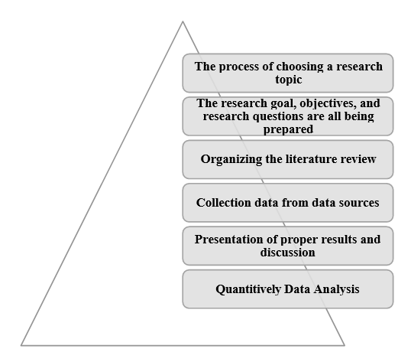

Figure 1 - Research Procedure

## Research Design

|  |  |  |
| --- | --- | --- |
| S. No. | Research Topic | Approach Used |
| 1. | Research Approach | Inductive Approach |
| 2. | Research Strategy | Grounded Theory |
| 3. | Research Philosophy | Positivism |
| 4. | Research Method | Quantitative |
| 5. | Data Collection | Primary |
| 6. | Data Analysis | Graphical Interpretation |

Figure 2 - Research Design

Based on the above table, the research design approach can be understood easily. The design of research demonstrates all the important methods and techniques used in the research which are needed for the collection of data (Sovacool, et al., 2018). It provides a general overview of all segments of a research methodology chapter.

## Research method

The study uses the quantitative approach of research to discover and solve problems addressed in the particular study. In research, mostly two types of qualitative and quantitative research methods are used. The process of gathering and interpreting numerical data is quantitative research (Chu and Ke, 2017). This may be used to identify patterns, forecast, evaluate causal linkages, and generalise results to broader groups. Quantitative research is widely used in the sciences of nature and society such as biology, chemical science, psychology, economics, sociology, and marketing. The quantitative research approach is mostly used for identifying patterns, averages, statistics, and mathematical forecasts. The quantitative method of research is most appropriate for the requirement of this research, and it is going to aid in the evaluation and generalisation of findings from primary data.

## Research philosophy

Research Philosophy refers to the assessment of knowledge in terms of assumptions and beliefs. Research philosophy is highly significant since the choice of research philosophy shows whether or not research takes the right methods, methodologies, and methods. There are several types of research philosophies such as positivism, interpretivism, pragmatism, postmodernism, and critical realism (Esser and Vliegenthart, 2017). The chosen philosophy of research is dependent on the needs of research. ***This study applies the philosophy of positivism research philosophy***. Positivism is a philosophy in which every valid knowledge is either positive and acquired only from the experience of natural things, their characteristics and relationships, or by definition, analytical and tautological. Thus, sensory-based information, as processed through reason and logic, constitutes the sole basis of all certain knowledge. Verified evidence from the senses is known as empirical evidence so positivism is focused on empiricism. Positivism philosophy adheres to the actual knowledge gain through observations including measurements and trustworthiness. Thereby this philosophy is selected as it will help to analyse the behaviour of youth on social media.

## Research Strategy

The research strategy sets forth the plan or path by which one can explore and answer questions from the research methodology chapter and the means to achieve research objectives and outcomes. Research strategy is often viewed as a link between the philosophy of research and methodology choice. Research strategies such as experiment, action research, ethnography, archives, and grounded theory are available for numerous options. The research employs grounded theory as the research strategy, based on the requirements of this study. Grounded theory, is a type of research that is concerned or associated with the generation of theory, it uses systematically gathered and analysed data that is grounded in nature. The primary use of it is to uncover such things as social relationships and behaviours of groups, which is also known as social processes (Park, et al.,2020). That is why it is extremely suitable to use this grounded theory method for a better analysis of youth’s behaviour on social media.

## Research Approach

The inductive research approach is used in this research. In the initialisation or beginning of the research of inductive studies, no theories of hypothesis apply. And the research provides freedom in terms of altering the line of direction for the study after its process had initialised. Deductive research approaches a hypothesis based on various statements and then concludes the best and finest assertion. Using the inductive methods research field questions are framed and analysed. Research is always inductively focused on the research issues. The current approach targets to create meanings from the collected data set to recognise patterns and connections to create a theory, although the inductive approach does not cease the use of existing theories to form or create the research question which is to be explored. When utilised and coupled with a positivism research philosophy, the inductive research methodology offers promising outcomes (Appelbaum, et al.,2018). This strategy helps the researcher examine the current circumstances of the research field and provides proof and facts. Furthermore, the inductive technique of research helps to analyse an amount of ambiguous and complex data. In this study, an inductive research approach is going to help to conclude and make the behavioural analysis of social media.

## Data Collection

In the respective research data, the collection topic is a very important approach for demonstrating the results of the research. The practise of collecting and measuring information on variables of interest is known as data collecting. Based on the facts gathered, a researcher might evaluate their hypothesis. Primary sources, secondary sources, and the mono technique are the three major categories of data collection sources are available in general. In this research, the data is collected from primary sources. Primary data can be collected in a variety of ways, including surveys and descriptive studies (Flick, 2017). ***The respective research is conducted with a dataset created by a third party through a survey questionnaire***. The respective study has been conducted based on survey answers provided by approximately 1600 participants from all over India who use social media technology. The questionnaire answers are collected from the participant by email. The survey questionnaire contains 19 close-ended questions based on the research area.

### Sampling

As the respective research is by Flick, (2017) the research can't include all the population in the research for the collection of primary data. So, the researcher used the sampling method for analyzing the data, in the respective study random sampling method is used for the identification of final results. The method of sampling provides equal opportunity for every observation of the respective study.

### Population

In the respective study, the main target population is concerned with the youngsters who use social media on regular basis for making better communication with their friends and family. Therefore, youngsters who have a good understanding of social media platforms and are observed using the platforms continuously will be approached. However, focusing on just the youngsters will introduce an inherent bias in the data, therefore the data collection will be unbiased and open-ended to keep the data as original as possible.

### Data Analysis

The analysis of the data is an important approach for the research. In the research, the data is analyzed based on primary data because primary data sources are being used in the research to evaluate the findings of the research. It is critical to properly interpret the information while conducting the research, as the study's results should be adequately framed in the conclusion. In the research, the graphical interpretation technique is used for the analysis of data and information (Viloria, et al., 2019). ***The graphical interpretation method is used in the research*** because it suggested several useful problem-saving techniques. It uses exploratory data analysis (EDA) as a key component. Graphical analysis is frequently used as the starting point for any problem-solving technique. The graphical analysis provides images of the data, which aids in the understanding of patterns and the relationship between process variables.

## Research limitations

The flaws or shortcomings which could be resulted from the unavailability of the resources, having a small sample size, and being caused by flawed methodology are called limitations of the study (Alase, 2017). In this research the sample size is very small near about fifty, therefore, the outcomes cannot be generalised for the wider population. The research outcomes are majorly dependent on the questionnaire’s response, hence there is no certainty of the respondent’s opinion as it can be fake or genuine. Another major limitation of this study is that there is no certainty of correct identification of the real-time behaviour of respondents, their body language, and responses. The single dependability of the research on the survey questionnaire’s responses creates unavailability of resources for a detailed study. By taking a large sample size and improving the quality of interventions, these limitations can be eradicated.

## Ethical Consideration

Ethics are the behavioural standards that govern the researchers in researching a safe and accurate way. In this research, all three fundamental criteria of data authenticity, data integrity, and data confidentiality are respected (Opie, 2019). Also, the privacy and safety of questionnaires are ensured. The research aims to learn more about social media youth behaviour and their experiences towards it. The research has been processed ethically and all personal data of questionnaires has been kept secrete. From any active data collection or intervention, participants are acknowledged that they are free to withdraw. From the program at any point without pressure or fear of retaliation when data is collected. Furthermore, the data collection is used for research purposes only hence no unauthorised person gets access to the data. The research is conducted following the confidentiality of each participant included in the research. All fundamental ethical considerations such as confidentiality, conflict of interest, benefit, non-maleficence, justice, honesty, informed consent have followed in the research study.

# EXPERIMENTATION

## Introduction

This chapter of the research is concentrated on data analysis and is aimed to generate the research findings. The graphical interpretation method has been used in this section for analysing the data collected from the online survey questionnaire. The response collected for 19 questions are represented in graphical form for effective interpretation. The interpretation is developed to identify the pattern between the collected data and to provide valuable outcomes from data analysis. An extensive discussion is provided for generalizing the outcomes of data analysis to the wider population.

## Data Interpretation

The dataset used is from a survey conducted in India regarding how much social media is being used by the residents. The data is collected as a survey from all over the country from a wide range of states covering all ages. The questions asked in the survey are as follows:

* Current employment status
* Multiple profiles on Instagram
* Gender
* Highest education
* Number of followers on Instagram
* Number of posts on Instagram
* Time spent on Facebook in a week
* Time spent on Facebook in a weekend
* Time spent on Instagram in a week
* Time spent on Instagram in a weekend
* Time spent on WhatsApp in a week
* Time spent on WhatsApp in a weekend

These questions were then used to calculate the total usage of social media for each person and also the total usage for each social media differently for each person. The timeframe that is considered for this data survey is a week before the questionnaire. A week consists of working days as well as the weekend. The data collected will now be interpreted according to each different question that was answered. Also, the demographic of the survey will be analyzed by graphically viewing the distribution of the cities and age groups the data has been collected from. This will provide us with deeper insight into the behaviour of the public when it comes to social media usage.

Figure 3 shows the distribution trend of the ages of the people that answered the survey. The Highest number of people belong in the teenager section. There is a sudden decrease after the (43, 58] age class. The reason behind this is the involvement of social media in workplaces and schools as part of the infrastructure. The age groups with the most users of social media correspond to either students or the working class that have already included social media in their communication infrastructure and are also using it to conduct important business. Also, social media is gaining more popularity as a news distribution network so this fact also contributes to the high number of people above age 35 in the survey.

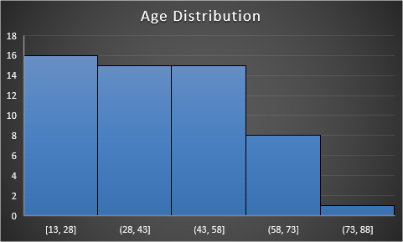

Figure 3 - Age Class Interval Distribution.

Figure 4 shows the distribution of the survey population based on the cities that participated in the survey. This can be insightful since it can be used to determine the cities that are developed enough to increase social media usage. From the graph, it can concur that the popular metropolitan cities of India i.e., Delhi, Mumbai and Kolkata rank the highest in social media usage. Other than the popular metropolitan cities, the northern cities of India have the most usage of social media usage. This is followed by southern Indian states. Although many of the western, more agriculture-oriented states haven’t participated in the survey, we can derive the fact that there is little to no availability of internet in the area which can be the reason that the people in those regions are deprived of social media. The trend that this graph follows can also be associated with the literacy rate of each area. Northern India has a much higher average literacy rate than the southern area and the comparison carries on with western India.

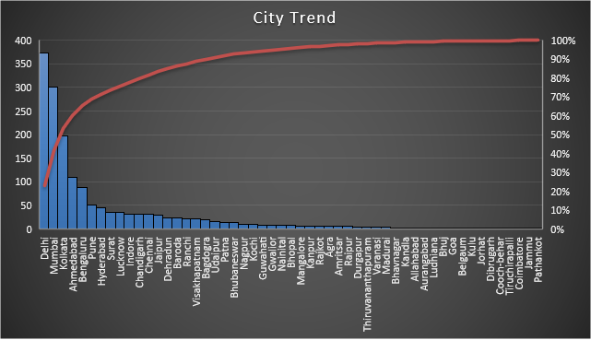

Figure 4 - Distribution of Survey Population, based on Cities.

Figure 5 - Distribution of Survey Population, based on Profession.

Figure 5 shows the graph for the distribution of the survey population based on the profession. This graph proves the derivation of the profession made previously from Figure 3 correct. As it can be observed from Figure 5, the professions with the most social media users are the working professionals and students which aligns perfectly with the derived hypothesis from Figure 3. This also proves the fact the social media has made its way into not only the entertainment infrastructure but also the professional infrastructure as the number of working professionals that use social media is even higher than the students.

Figure 6 - Average Followers on Instagram based on Profession.

The distribution of followers on Instagram somewhat deviates from the normal perception that was assumed in Figure 6. The fact that working-class professionals have the most followers is understandable since they spend more time on their phones for work, coincidentally they spend more time on their phones for leisure. However, sabbatical people having the 2nd most average followers is unexpected. This might be because of the quality of content posted by the sabbatical people. Sabbatical people are people that travel due to business or education. Since they travel, they keep track of their travels by posting on social media. This increases the quantity and the quality of the content posted on their accounts that attracts more people. This hypothesis can be the only explanation for the fact that sabbatical people have the second-highest following.

Figure 7 - Average Number of Posts on Instagram.

Despite the number of posts being higher for the self-employed, the average number of followers for self-employed people are the least. This proves the hypothesis that sabbatical people have the second-highest average following on Instagram due to the quality of the posts.

## Data Interpretation using Code

The data will be further analyzed statistically using the statistical and graphical features provided by Python – the programming language. The first hypothesis targeted is the fact that people tend to stay more online on the weekends rather than on weekdays. This hypothesis can be visualized as follows:

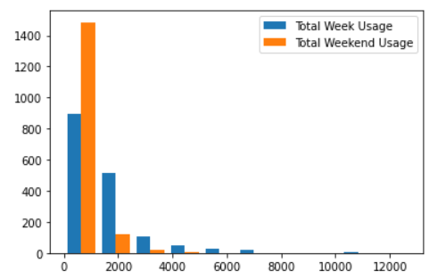

Figure 8 - Usage of Social Media on Weekends vs on Weekdays.

The Histogram gives a good look at the Weekend Usage vs Weekly Usage and it seems our hypothesis is correct. Let's use a Probability Mass Function to Visualize and be sure about our claim.

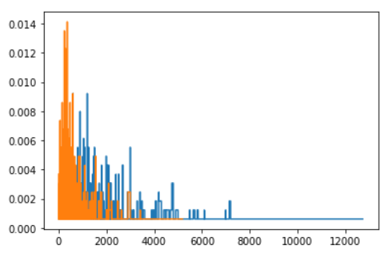

Figure 9 - Probability Mass Function for Hypothesis 1.

It looks like our Hypothesis is True. From the PMF we can be sure that there is more Weekend Usage than Weekly Usage. For the second hypothesis, we can consider the popularity shift from Facebook to Instagram. This can be visualized as follows:

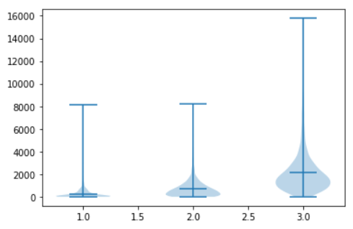

Figure 10 - Violin Plot for Hypothesis 2.

Looks like there are more users of Instagram than Facebook. To be surer let us get rid of the Non-Facebook and Instagram users, i.e., users who have 0 usages for Facebook or Instagram.

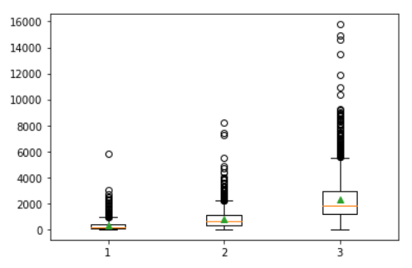

Figure 11 - Boxplot for Hypothesis 2.

Looking at both the Box Plot and Violin Plot, we can now be sure that people are indeed shifting to Instagram from Facebook. Now let us have an analysis amongst Facebook Users, Instagram Users and if and how they relate to the number of Instagram Followers.

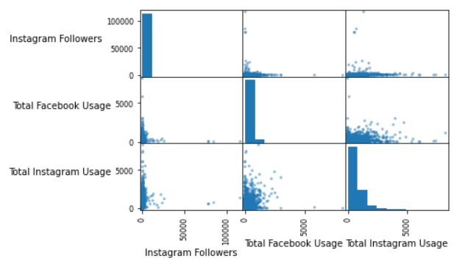

Figure 12 - Relation between Instagram and Facebook Preferences.

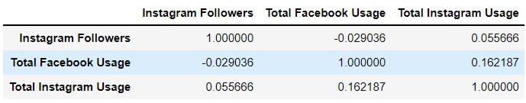

Figure 13 - Correlation Matrix Representation for Figure 12.

Although the Scatter Matrix did not tell us much, we can see from the Correlation Matrix that the number of Instagram Followers are negatively correlated with Facebook Usage. Hence, we can say that the more the number of Instagram Followers people get, the less they visit Facebook. It is also intuitive and validated from the Correlation Matrix that more Instagram Followers leads to more Instagram Usage and vice-versa. We see that parents scold their kids when they visit Social Media very often and ask them to concentrate on their studies as Social Media might distract them. Let us validate their claims with this hypothesis that People with more degrees tend to have less Total Social Network Usage.

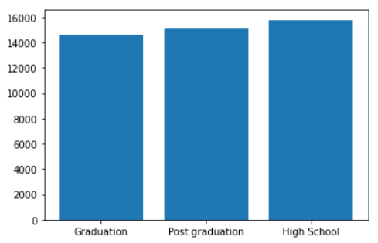

Figure 14 - Representation of Hypothesis that People with more degrees tend to have less affinity towards social media.

Now we have conclusive proof that our assumption might not be correct! We see that people with Post Graduate degrees tend to use social media more than people having Graduation degrees only. Can this be because people with Graduation tend to get into industrial jobs than people with Post Graduation degrees as people with PG degrees tend to get into academics and go for further studies? Let's verify this.

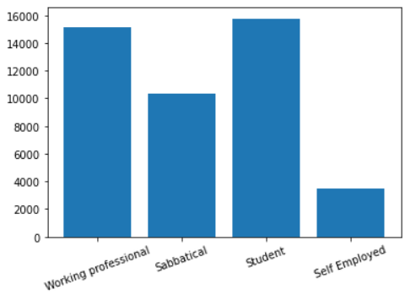

Figure 15 - Representation of the Hypothesis that People in the Working Profession tend to visit Social Media less than others.

We see from the bar chart that although Working Professionals visit social media less than Students (Intuitive), it is not always true that Working Professionals tend to visit Social Media less than other people. We can see that people who have taken Sabbatical visit social media less than Students and Working Professionals. People who are Self Employed are lesser. We can interpret and infer various reasons for this! Let us go back to our Instagram Analogy. We saw the rise and shift of Instagram from Facebook. Can we also say that Working professionals are shifting to Instagram lesser than others?

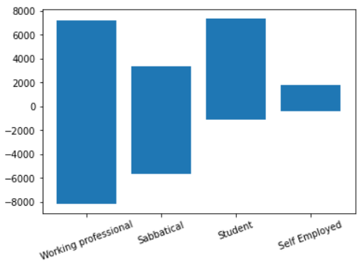

Figure 16 - Representation of the Hypothesis that Working Professionals are not shifting to Instagram as much as others.

We can see from the bar chart that Working Professionals are using as much Facebook as they are using Instagram. This is also almost true for people with Sabbatical. But we see a clear shift to Instagram for Students. The new generation seems to love Instagram.

# Discussion

Based on the given data and the response of the question it has been observed that social media impact highly on the life of human beings. The day-to-day use of technologies has increased which has exploded the use of social media platforms for the youth (Anderson and Jiang, 2018). Youth is spending more than required time on the online platforms of social media which is responsible to create disturbances related to health, studies, and affects life negatively. Using social media correctly can give positive outcomes in the technical era, but at the same time spending much time and using it improperly can hamper the daily schedules of the youth and people of all ages. Using social media properly can enhance the personal development and the skills of human beings, but it can negatively impact balance and the coordination to manage the work. It has been observed that the use of social media networking is becoming popular in the youth of newer generations and almost 70% of the youth is impacted by the scenario. The number of male and female social media users cannot be justified because every single person is addicted to it.

87% of the youth is addicted to social media platforms which are responsible to create a high disturbance in the study and extra curriculum activities. Social media networking is influencing the behaviour of younger people which is responsible to create a disturbance in personal as well as professional life. The use of smartphones and the internet have created a lot many challenges in the behaviour of people (Chukwuere and Chukwuere 2017). The speed at which the news travels across the globe has become faster with the advancement and development of technologies. The negative news can impact the life of living beings and can create physical and mental stresses in the mind. Watching programs and television can create entertainment for the short-term only, but at one or the other point, it is responsible to affect a healthy life as well. Thousands of social media channels are responsible to change the view of the people towards social issues, which can create the worst issue for society.

Social media can help to provide ample opportunities as well which can enhance the skills and can create a healthy environment, but it needs accurate and precise data which can not misguide the people. The culture and the dressing sense are highly and negatively impacted by the increasing social media network. It is analysed in the observation that social media networking is developing the comparative attitude over improper aspects which can create hurdles in the personal life. The negative impact of the social media platform is spreading due to the lack of knowledge. People of different ages are not able to distinguish between fantasy and reality. The media is responsible to feed the minds of youth with disturbances and violent issues (Akram and Kumar, 2017). The misbehaviour against people is increasing due to the negative attack of the various platforms. 46% of the people are agreed with the statement that social media networking is developing the racist mentality in the kinds of youth and adolescents.

The impact of social media can be degraded with the proper knowledge. It has been reported that the psychology of the human mind is directly in the control of social media. People are using social media with the wrong interpretation of information which is responsible to disturb the impact of society. The high use of media plays a significant role to negatively affect health factors. The provoke criticism tends to mislead the picture of reality (Giunchiglia, et al., 2018). Everything is developing based upon the need of the people which is influencing the youth to be addicted to social media. Media is influencing the mindset of the people in various aspects as mentioned above, which is responsible to harm the surrounding at every single point. The use of social media should be less so that education, health issues, and culture cannot be negatively impacted by society.

# CONCLUSION AND RECOMMENDATIONS

## Introduction

This segment helps look after the details and the factors which are proposed in the research. The conclusion helps relate all the concepts of the research and then a collective response and result are generated, while the recommendations help in understanding the aspects for the future in a better manner. The recommendations are defined depending upon the outcomes gauged through the conclusion.

Conclusion

**According to objective 1,** it could be concluded that the involvement of the youth in using social media platforms is increasing at a rapid rate. Certain aspects require to be looked after by the guardians of the youth. The activities of the youth should be monitored, and the time which the youth are investing should also be limited. In most cases, people do not consider that investing time in social media could result in unproductivity. The major reason which directs the youth towards social media is the content, the content is now being developed to target the youth and the young generation is more responsive towards the content available.

**According to objective 2,** there are different social media platforms used by the youth. Most of the time which is spent on social media by the youth is just for entertainment. It could be considered that the primary use of social media was to initiate communication with the people and to have a healthy interaction with the world. Gradually the platforms are now offering multiple services. People could post pictures, videos, and can also share the experience through words. All these things are progressively increasing the involvement of the youth in the network. There are different aspects associated with the usage, in consideration of the advantages of social media. The youth get to learn many new things, social media helps in learning new techniques and also helps in staying updated with the world. Social media also helps in portraying the information and news of different places which the media could not do. It is a fast and easy method of spreading awareness. Moreover, there are some negative impacts of social media as well, youth get distracted from the actual goal. As the generating is growing it is becoming difficult for the youth to understand the difference between real life and the virtual world.

**According to objective 3,** the impact of social media on the youth needs to be looked after properly. Several aspects are impacted by the excessive use of social media. In consideration of the positive impacts, the youth are now able to deal with the social issues properly, they are learning awareness regarding the society and technology. Moreover, a positive competitive spirit is also being developed in the hearts of the youth. This spirit helps in combating the issues and building up a better version. It has certain drawbacks as well; the excessive use of social media is impacting the living of the youth. It could be seen that the youth are not getting involved in physical sports and are spending time over the devices. This is also dragging the youth in the digital life, rather the actual essence of the living is being taken away from the youth. The actual development of the personality could only be done if the youth are involved in the real world and the activities are being done progressively. But, social media is not letting the youth gain actual growth. The innocence of childhood is somehow being snatched by the overuse of social media.

**According to objective 4,** it could be brought to the conclusion that social media has been influencing the lives of the people at a great level, majorly the youth are involved in this. The influence could be gauged as most of the youth want to follow the social media influencers. The trend of the celebrities or the trend which is set by the social media influencers is impacting daily life. Youth want to dress like celebrities, it could also be seen that the youth also want to live the life which the influencers are living. This is not an appreciable step, as people should consider that the real personality is being dominated through the excessive use of social media. These different applications lead the generation towards the trend, another most impactful thing is that the trend is designed to attract the youth. If one trend gets obsolete then social media serves as a new trend for the youth to follow. All these aspects could define that the influence of social media over the lives of the youth is impacting with a great density.

# Recommendations

The use of social media is increasing day by day which is responsible to affect the life of living beings. With the increasing use of social media, people are getting addicted to the scenario. Youth should understand the value of social media and use it according to the requirements to enhance the value of the task. Different platforms should recognize the evaluation process of the customer that can help in controlling the social network. People should use accurate information and data to spread through the source of the internet. People should generate positive skills with the different platforms that can help in the personal as well as overall development (Boulianne, et al., 2020).

People should spend less time on social applications and must give time to priorities. The programs and TV channels must encrypt the accurate information so that the format of misinformation can be reduced. The social networking channels must protect sensitive data to reduce crimes. The youth should gain the proper knowledge and must use the platform to acquire the skills that can help in the development (Boulianne, et al., 2020). The parents are recommended to be updated with the activities of the kids on the social platforms. The youth must understand the difference between fantasy and reality on social platforms which is attracting a lot of interest.

# References

1. Abi-Jaoude, E., Naylor, K. and Pignatiello, A., 2020. Smartphones, social media use and youth mental health. Canadian Medical Association Journal, 192(6), pp.E136-E141.
2. Akram, W. and Kumar, R., 2017. A Study on Positive and Negative Effects of Social Media on Society. International Journal of Computer Sciences and Engineering, 5(10), pp.351-354.
3. Alase, A., 2017. The Interpretative Phenomenological Analysis (IPA): A Guide to a Good Qualitative Research Approach. International Journal of Education and Literacy Studies, 5(2), p.9.
4. Anderson, M. and Jiang, J., 2021. Teens, social media & technology 2018. [online] Apo.org.au. Available at: <https://apo.org.au/node/175701> [Accessed 22 August 2021].
5. Aparicio-Martinez, P., Perea-Moreno, A., Martinez-Jimenez, M., Redel-Macías, M., Vaquero-Abellan, M. and Pagliari, C., 2019. A Bibliometric Analysis of the Health Field Regarding Social Networks and Young People. International Journal of Environmental Research and Public Health, 16(20), p.4024.
6. American Psychologist, 2018. “Journal article reporting standards for quantitative research in psychology: The APA Publications and Communications Board Task Force Report”: Correction to Appelbaum et al. (2018). 73(7), pp.947-947.
7. Baccarella, C., Wagner, T., Kietzmann, J. and McCarthy, I., 2018. Social media? It's serious! Understanding the dark side of social media. European Management Journal, 36(4), pp.431-438.
8. de Ávila, G., dos Santos, É., Jansen, K. and Barros, F., 2020. Internet addiction in students from an educational institution in Southern Brazil: prevalence and associated factors. Trends in Psychiatry and Psychotherapy, 42(4), pp.302-310.
9. Charoensukmongkol, P., 2017. The Impact of Social Media on Social Comparison and Envy in Teenagers: The Moderating Role of the Parent Comparing Children and In-group Competition among Friends. Journal of Child and Family Studies, 27(1), pp.69-79.
10. Chen, T., Hui, E., Wu, J., Lang, W. and Li, X., 2019. Identifying urban spatial structure and urban vibrancy in highly dense cities using georeferenced social media data. Habitat International, 89, p.102005.
11. Chu, H. and Ke, Q., 2017. Research methods: What's in the name?. Library & Information Science Research, 39(4), pp.284-294.
12. Collins, R., Strasburger, V., Brown, J., Donnerstein, E., Lenhart, A. and Ward, L., 2017. Sexual Media and Childhood Well-being and Health. Paediatrics, 140(Supplement 2), pp.S162-S166.
13. Décieux, J., Heinen, A. and Willems, H., 2018. Social Media and Its Role in Friendship-driven Interactions among Young People: A Mixed Methods Study. YOUNG, 27(1), pp.18-31.
14. Dilci, T. and Eranıl, A., 2019. The Impact of Social Media on Children. Handbook of Research on Children's Consumption of Digital Media, pp.1-10.
15. Ernst, N., Esser, F., Blassnig, S. and Engesser, S., 2018. Favourable Opportunity Structures for Populist Communication: Comparing Different Types of Politicians and Issues in Social Media, Television and the Press. The International Journal of Press/Politics, 24(2), pp.165-188.
16. Esser, F. and Vliegenthart, R., 2017. Comparative Research Methods. The International Encyclopedia of Communication Research Methods, pp.1-22.
17. Giunchiglia, F., Zeni, M., Gobbi, E., Bignotti, E. and Bison, I., 2018. Mobile social media usage and academic performance. Computers in Human Behavior, 82, pp.177-185.
18. Goodyear, V., Armour, K. and Wood, H., 2018. Young people and their engagement with health-related social media: new perspectives. Sport, Education and Society, 24(7), pp.673-688.
19. Jan, M., Soomro, S. and Ahmad, N., 2017. Impact of Social Media on Self-Esteem. European Scientific Journal, ESJ, 13(23), p.329.
20. Maduro, M., 2018. Possibilities of Psychological Intervention on Social Networks. Acta Educationis Generalis, 8(3), pp.35-49.
21. Kilian, T., Hennigs, N. and Langner, S., 2012. Do Millennials read books or blogs? Introducing a media usage typology of the internet generation. Journal of Consumer Marketing, 29(2), pp.114-124.
22. Kumar, N., Nagalla, R., Marwah, T. and Singh, M., 2018. Sentiment dynamics in social media news channels. Online Social Networks and Media, 8, pp.42-54.
23. McCrae, N., Gettings, S. and Purssell, E., 2017. Social Media and Depressive Symptoms in Childhood and Adolescence: A Systematic Review. Adolescent Research Review, 2(4), pp.315-330.
24. Megele, C. and Buzzi, P., n.d. Social media and social work.
25. Nygren, G., 2019. Local Media Ecologies. Nordicom Review, 40(s2), pp.51-67.
26. Opie, C. and Brown, D., n.d. Getting started in your educational research.
27. Chen, X. and Wei, S., 2019. Enterprise social media use and overload: A curvilinear relationship. Journal of Information Technology, 34(1), pp.22-38.
28. Park, Y., Konge, L. and Artino, A., 2020. The Positivism Paradigm of Research. Academic Medicine, 95(5), pp.690-694.
29. Purohit, H & Chan, J 2017, 'Classifying user types on social media to inform who-what-where coordination during crisis response', Proceedings of the International ISCRAM Conference, vol. 2017-May, pp. 656-665.
30. RAI, D., 2017. Impact of Social Networking Sites (SNSs): Are Youth affected by its usage?. Issues and Ideas in Education, 5(1), pp.11-24.
31. Štreimikienė, D., Mikalauskienė, A., Sturienė, U. and Kyriakopoulos, G., 2021. The Impact of Social Media on Sales Promotion in Entertainment Companies. E+M Ekonomie a Management, 24(2), pp.189-206.
32. Salomon, I. and Brown, C., 2018. The Selfie Generation: Examining the Relationship Between Social Media Use and Early Adolescent Body Image. The Journal of Early Adolescence, 39(4), pp.539-560.
33. S, S., SATHEESHKUMAR, R. and KUMAR, V., 2019. A STUDY ON THE IMPACT OF SOCIAL MEDIA ON YOUTH. JOURNAL OF MANAGEMENT, 6(1).
34. Shahbaznezhad, H., Dolan, R. and Rashidirad, M., 2021. The Role of Social Media Content Format and Platform in Users' Engagement Behavior. Journal of Interactive Marketing, 53, pp.47-65.
35. Akram, W. and Kumar, R., 2017. A Study on Positive and Negative Effects of Social Media on Society. International Journal of Computer Sciences and Engineering, 5(10), pp.351-354.
36. Sovacool, B., Axsen, J. and Sorrell, S., 2018. Promoting novelty, rigour, and style in energy social science: Towards codes of practice for appropriate methods and research design. Energy Research & Social Science, 45, pp.12-42.
37. Stevens, R., Gilliard-Matthews, S., Dunaev, J., Todhunter-Reid, A., Brawner, B. and Stewart, J., 2017. Social Media Use and Sexual Risk Reduction Behavior Among Minority Youth. Nursing Research, 66(5), pp.368-377.
38. Sharma, M., 2018. A Regional Perspective of Crime Statistics: The Case of Haryana. JOURNAL OF SOCIAL SCIENCES, 55(1-3).
39. Wohn, D., Ellison, N., Khan, M., Fewins-Bliss, R. and Gray, R., 2013. The role of social media in shaping first-generation high school students' college aspirations: A social capital lens. Computers & Education, 63, pp.424-436.
40. Zhang, T., Abound Omran, B. and Cobanoglu, C., 2017. Generation Y’s positive and negative eWOM: use of social media and mobile technology. International Journal of Contemporary Hospitality Management, 29(2), pp.732-761.
41. Akbar, Z., Fensel, A. and Fensel, D., 2017. Enabling Analysis of User Engagements Across Multiple Online Communication Channels. Metadata and Semantic Research, pp.147-159.